Project Planning Phase

Project Planning Template (Product Backlog, Sprint Planning, Stories, Story points)

|  |  |
| --- | --- |
| Date | 22 October 2022 |
| Team ID | PNT2022TMID00415 |
| Project Name | Inventory Management System for Retailers |

Product Backlog, Sprint Schedule, and Estimation (4 Marks)

Use the below template to create product backlog and sprint schedule

|  |  |  |  |  |  |  |
| --- | --- | --- | --- | --- | --- | --- |
| **Sprint** | **Functional**  **Requirement (Epic)** | **User Story Number** | **User Story / Task** | **Story Points** | **Priority** | **Team Members** |
| Sprint-1 | Registration | USN-1 | As a user, I can register for the application by entering my email, password, and confirming my  password. | 2 | High | Anush Niranchan  Arun katir  Gowtham raj  Harishvardhan |
| Sprint-1 |  | USN-2 | As a user, I can register for the application through E-mail | 1 | Medium | Anush Niranchan  Arun katir  Gowtham raj  Harishvardhan |
| Sprint-1 | Confirmation | USN-3 | As a user, I will receive confirmation  email once I have registered for the application | 2 | Medium | Anush Niranchan  Arun katir  Gowtham raj  Harishvardhan |

|  |  |  |  |  |  |  |
| --- | --- | --- | --- | --- | --- | --- |
| **Sprint** | **Functional Requirement (Epic)** | **User Story Number** | **User Story / Task** | **Story Points** | **Priority** | **Team Members** |
| Sprint-1 | Login | USN-4 | As a user, I can log into the application by entering email & password | 2 | High | Anush Niranchan  Arun katir  Gowtham raj  Harishvardhan |
| Sprint-2 | Dashboard | USN-5 | As a user, I can view the products which are available | 4 | High | Anush Niranchan  Arun katir  Gowtham raj  Harishvardhan |
| Sprint-2 | Add items to cart | USN-6 | As a user, I can add the products I wish to buy to the carts. | 5 | Medium | Anush Niranchan  Arun katir  Gowtham raj  Harishvardhan |
| Sprint-3 | Stock Update | USN-7 | As a user, I can add products which  are not available in the dashboard to the stock list. | 5 | Medium | Anush Niranchan  Arun katir  Gowtham raj  Harishvardhan |
| Sprint-4 | Request to Customer Care | USN-8 | As a user, I can contact the  Customer Care Executive and request any services I want from the customer care. | 5 | Low | Anush Niranchan  Arun katir  Gowtham raj  Harishvardhan |
| Sprint-4 | Contact  Administrator | USN-9 | I can be able to report any difficulties I experience as a report | 5 | Medium | Anush Niranchan  Arun katir  Gowtham raj  Harishvardhan |

Project Tracker, Velocity & Burndown Chart: (4 Marks)

|  |  |  |  |  |  |  |
| --- | --- | --- | --- | --- | --- | --- |
| **Sprint** | **Total Story Points** | **Duration** | **Sprint Start Date** | **Sprint End Date (Planned)** | **Story Points Completed (as on Planned End Date)** | **Sprint Release Date (Actual)** |
| Sprint-1 | 7 | 6 Days | 24 Oct 2022 | 29 Oct 2022 | 7 | 28 Oct 2022 |
| Sprint-2 | 9 | 6 Days | 31 Oct 2022 | 05 Nov 2022 | 9 | 04 Nov 2022 |
| Sprint-3 | 5 | 6 Days | 07 Nov 2022 | 12 Nov 2022 | 5 | 11 Nov 2022 |
| Sprint-4 | 10 | 6 Days | 14 Nov 2022 | 19 Nov 2022 | 10 | 18 Nov 2022 |

|  |  |  |  |
| --- | --- | --- | --- |
| **Sprints** | **Sprint Duration** | **Velocity** | **Actual Velocity** |
| **Sprint-1** | **6** | **7** | **0.85** |
| **Sprint-2** | **6** | **9** | **0.66** |
| **Sprint-3** | **6** | **5** | **1.2** |
| **Sprint-4** | **6** | **10** | **0.6** |

**Velocity:**

Burndown Chart:



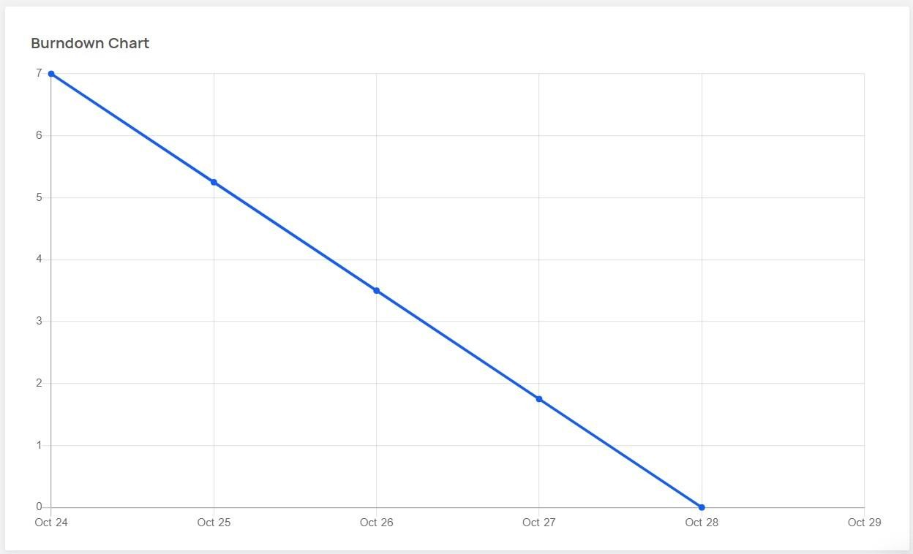

Sprint - 1

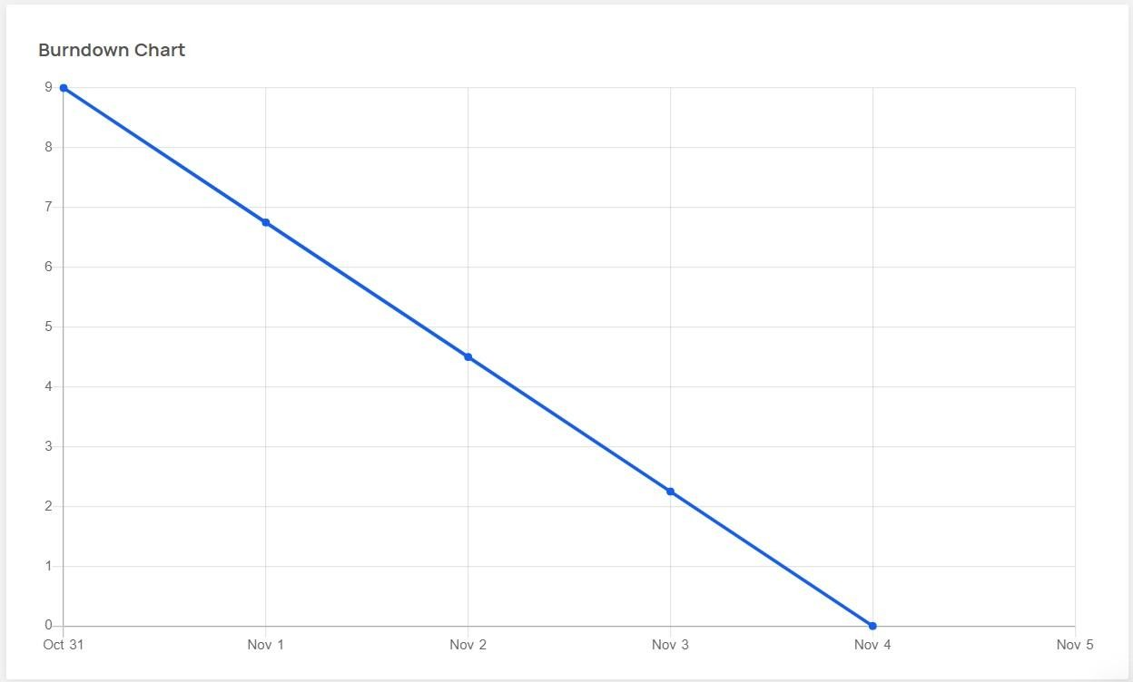

Sprint – 2

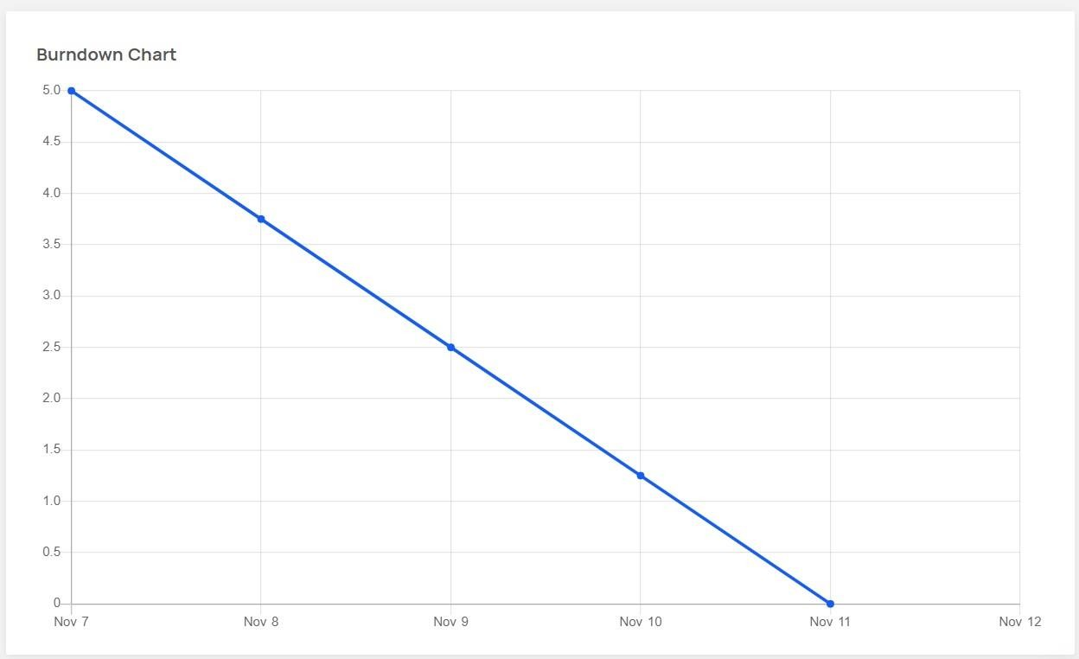

Sprint - 3

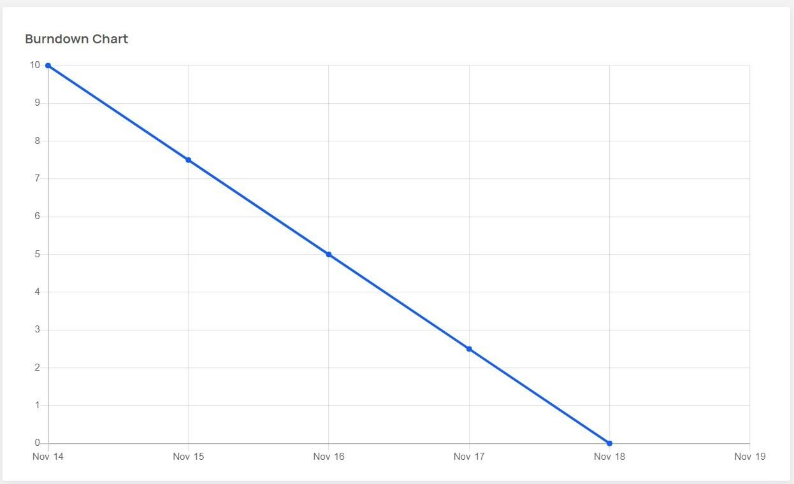

Sprint – 4

**PROJECT TOOL: JIRA**